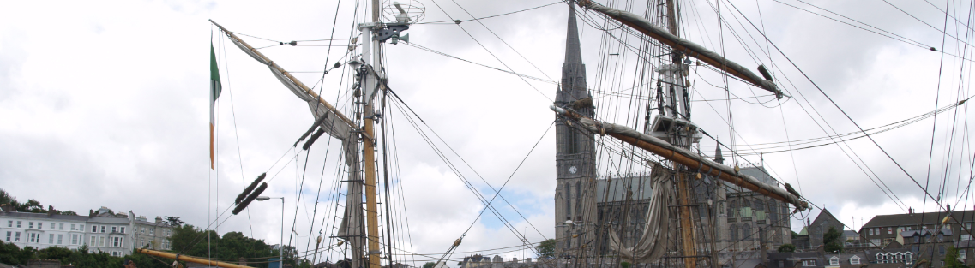
Cobh Tradational Sail Regatta

Cobh Traditional Sail Regatta 2012
Notice of Race and Sailing Instructions
Classic Regatta week of 29th of June to Sunday July 2st

A1 ORGANISING AUTHORITY
The Organising Authority [OA] is COVE SAILING CLUB, Naval Service Yacht Squadron and Cobh Traditional Sail

A2 RULES & ADVERTISING
The series will be governed by the Racing Rules of Sailing (RRS), the Prescriptions of the Irish Sailing Association (ISA), ECHO handicapping system Rules, the Rules of SCORA, Class Association Rules where applicable, this Notice of Race and Sailing Instructions.
ECHO handicaps will be taken from the current SCORA handicap lists.
The WhiteSail classes will be scored under ECHO ONLY.
This is a CATEGORY C event [ISAF REG 20]. Competitors may be required to carry advertising for Event Sponsors.

A3 ADVERTISING
5.1 The Blue Pennant (supplied with the Skippers pack) is required to be flown from the backstay as a means of identifying the vessels participating in the regatta.

A4 ELIGIBILITY AND ENTRY
1 The regatta is open to all ‘classic’ sailing yachts and dinghies, and modern cruising yachts.
2 Eligible boats may enter by completing the Entry Form available online at: www.cobhtradsail.com and sending it by post, together with the required fee, to Brian Curtis, Secretary, Cobh Trad Sail 11 Connolly St, Cobh, Co. Cork. Or by email with payment at registration to Cobh Traditional Sailing Secretary Brian Curtis brianjcurtis@gmail.com, or entries and Payment may be made at registration.

3 Yachts that are in possession of a Rating Certificate of any type are requested to submit these Certificates upon registration.
4 All competitors shall comply with the ISA or their own National Authority eligibility requirements.

A5 SAFETY
The safety of a boat and her crew is the sole and inescapable responsibility of the person in charge who must do his best to ensure that the yacht is fully found, thoroughly seaworthy and manned by an experienced crew who have undergone appropriate training and are physically fit and properly clothed to face bad weather. The person in charge must be satisfied as to the soundness of hull, steering equipment, spars, rigging, sails and all gear. He must ensure that all safety equipment is properly maintained and stowed and that the crew knows where it is kept and how it is to be used. The person in charge accepts that the responsibility for a boat’s decision to participate in a race or to continue racing is his alone. Neither these regulations nor any action of the organizing authority in any way limits or reduces the complete and unlimited responsibility of the owner or the person in charge.

A6 HINDERING BOATS AT START LINE
Boats not in their starting sequence shall avoid the area of the start line and shall not hinder boats preparing to start. The Protest Committee may penalise a boat for failing to comply with this Sailing Instruction with a score of its discretion, including DNC.

A7 Classes and CLASS FLAGS
1 The Yellow Pennant (supplied with the Skippers pack) is required to be flown from the backstay as a means of identifying the vessels participating in the regatta.

2 The OA reserves the rite to place any boat in any class it deems appropriate. The OA also reserves the rite to combine classes if numbers of entries does not justify separate classes.

A8 CHANGES IN SAILING INSTRUCTIONS AND NOTICES TO COMPETITORS
Changes in Sailing Instructions and/or Notices to Competitors will be posted on the www.covesailingclub.ie or www.cobhtradsail.com
Changes to these Sailing Instructions will be posted not later than 10.00 on the day of the race.

A9 MARKS AND COURSES.
Courses will be” around the cans” and may be taken from the Harbour Course Card.
Courses will be given on CH 69.

A10 START LINE & FINISH LINE
The START line shall be formed by the committee boat and a navigation buoy or a yellow mark.
The committee boat is a mark of the course at the start and finish of the race.
A buoy may be laid off the committee boat; no boat shall pass between this buoy and the committee boat at any time

A11 SCHEDULE
1 Registrations: Friday 29th of June 20.00
2 Skipper’s Briefing: Saturday 30th of June 12.00 and Sunday 1st of July at 12.00 hrs
3 Racing for all classes:
Saturday, June 30th
Sunday, July 1st plus Parade of Sail
4 There will be 1 race per day for all harbour classes, except Sunday the 26th, when there will be a Parade of Sail.

A12 LATE STARTING
A boat starting later than 10 minutes after her starting signal shall be scored DNS; this changes RRS A4.1

A13 TIME LIMITS
The time limit shall be 14.00 hrs. Any boat that finishes after the time limit will be scored DNF. This amends RRS 35.

A14 BERTHING
1 Visitor Berthing is available at the Quays Bar and Restaurant Cobh (60 meters Pontoon), a number of spaces will be assigned to visiting fleets, vessels should contact the Berthing Master on mobile 087-3574866 he will allocate a berth for each vessel.

A15 NOTIFICATION OF TAKING ALTERNATIVE PENALTIES AND INTENTION TO PROTEST
Competitors are reminded of the requirement under RRS 44.3 to notify the committee boat of having taken an alternative penalty before leaving the finish area.
In addition to the requirements under RRS 61 yachts must draw the attention of the Committee Boat to an intention to protest before leaving the finish area.

A16 PROTESTS

All protests shall be lodged only on official Protest Forms, which will be available at the Quay’s Bar
Protests shall be lodged to the OD as soon as possible and in any case not later than 30 minutes after the last yacht in the class finishes its race unless the Protest Committee has reason to extend this time. This changes RRS 61.3
It is the responsibility of the PROTESTOR to inform the PROTESTEE of the lodging of the protest, the likely time and place of the hearing and to supply him with a copy thereof. It is the responsibility of all parties thereafter to attend at the time and place of any hearing with their witnesses.

A17 RADIO COMMUNICATIONS
Competitors are advised to keep a listening watch on VHF Channel 69 where information relevant to racing may be broadcast. Should this information be broadcast, it shall not constitute outside assistance and shall not be the subject of any protest. Failure to broadcast this information shall not be the basis for any claim for redress.
Competitors who retire from a race shall inform the Race Committee promptly by radio on VHF Channel 69.

A18 DISCLAIMER OF LIABILITY
18.1 Cove Sailing Club, Naval Service Yacht Squadron, Cobh Traditional Sail and Members thereof, and any event Sponsor, are providing this series of races only on the understanding that the Club, its members, or the Sponsor, or its representatives, bear no responsibility whatsoever for any loss, damage or injury to any yacht or person howsoever arising, directly or indirectly by any accident or wrongful or negligent act, default or omission of any person during the event.

18.2 It is the sole and exclusive responsibility of each owner or owners’ representative to decide whether or not to start or continue to race.

18.3 Owners shall acknowledge their responsibility on the Official Entry Form and draw the attention of their crew and associates to this disclaimer Yacht owners, helms and crew shall ensure that they are adequately insured against loss, damage or injury to persons, yachts or equipment at all times and however occurring
A19 INSURANCE
Boat owners and crew shall ensure that they are adequately insured against loss, damage or injury to persons, boats or equipment at all times and however occurring and shall maintain adequate third party insurance cover and shall produce a valid certificate of insurance upon request.

A20 FURTHER INFORMATION
1 For further information and updates check the Cobh Traditional Sail website at: www.cobhtradsail.com

A20 PRIZEGIVING
There will be a prize giving in Quay’s Bar

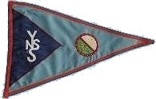
Naval Service Yacht Squadron Cove Sailing Club

